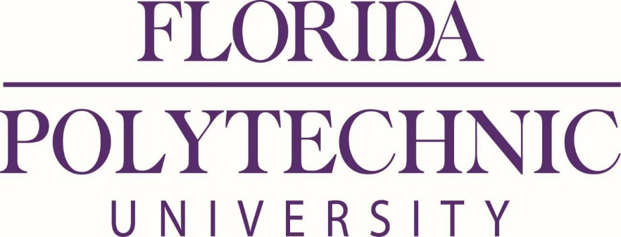

EVALUATION COMMITTEE MEETING

ITN 16-027 DMA –DSC SYSTEMS

Monday, October 24, 2016 at 8:00 am

Florida Polytechnic University
4700 Research Way
Lakeland, FL 33805

IST Room 1044

The Evaluation Committee for the University Dining Services Management, ITN 16-027 will convene at approximately 8:00 AM ET. to discuss the proposals received. The public is invited to attend and observe.

David O’Brien
Director of Procurement

